Day 1 – Basic Electronics

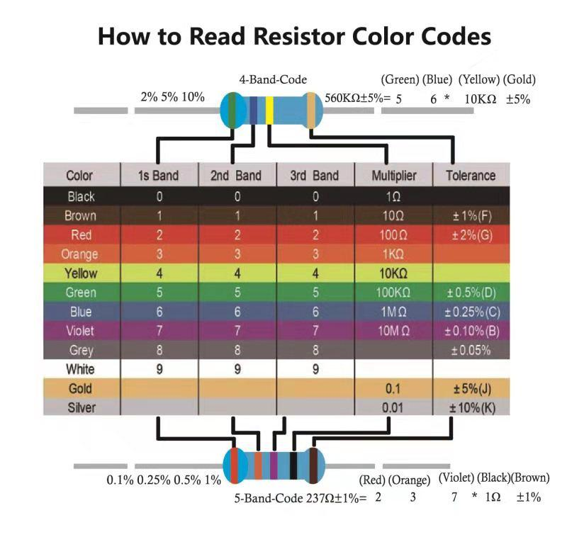

Can you determine the resistance

of the following resistors?

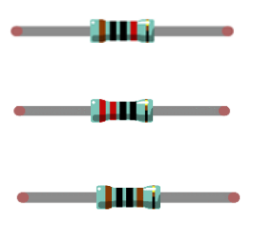

- Connecting an LED to GPIO Port 22

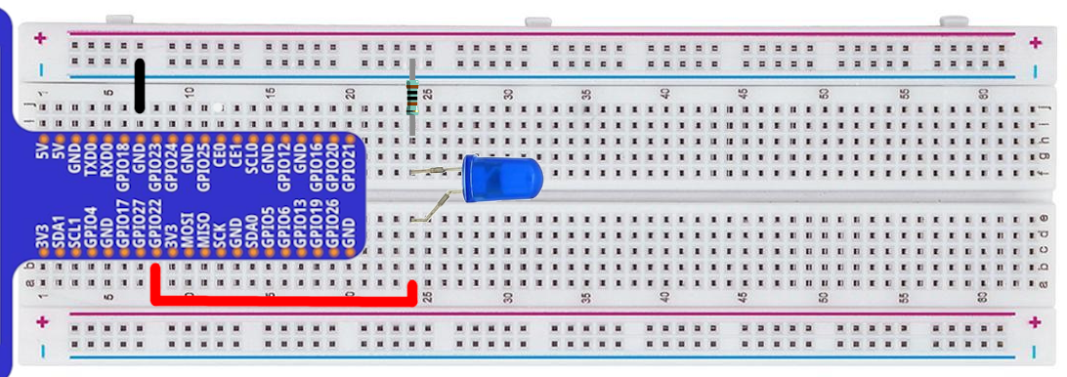

In the terminal start the python interpreter: python3

Note that >>> denotes the interpreter prompt - you don't type these characters

Also, anything that follows a '#' is a comment - it doesn't need to be typed either

>>> from gpiozero import LED

>>> led1 = LED(22) # telling python led1 is an LED on GPIO port 22

>>> led1.blink(.4, .4) #this will cause it to turn on/off every 0.4 seconds

>>> led.on() #this will turn it on

>>> led.off() #this will turn it off

>>> led.close() #when you're done

Day 1 – Basic Electronics

**Interrupting the circuit with a button**

A button can be used to break the circuit

When the button is pressed, the electricity can flow

This is not controlled by code

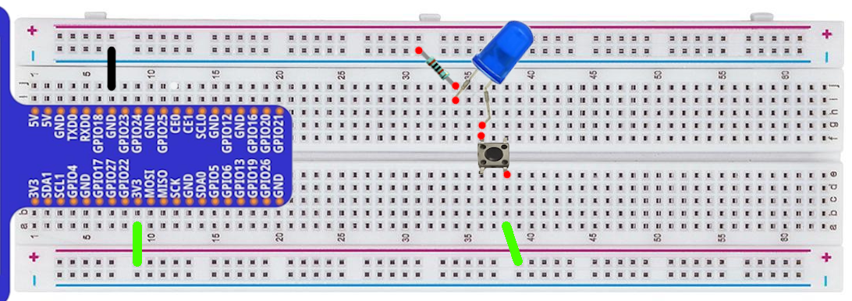

**Connecting a button to a GPOI pin**

GPIO 22 controls the LED

GPIO 27 reads the status of the button

Try the following

>>> from gpiozero import LED

>>> from gpiozero import Button

>>> led1 = LED(22)

>>> button1 = Button(27)

>>> button1.when_pressed = led1.on # turn the light on when the button is pressed

>>> button1.when_released = led1.off # turn the light off when the button is released

>>> button1.when_pressed = led1.blink # blink while the button is pressed

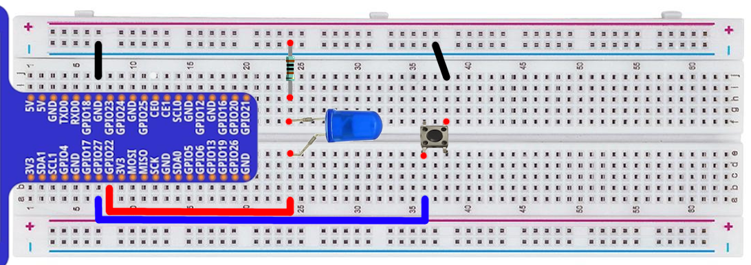

Day 1 – Basic Electronics

**RGB Led**

The long pin is the anode - it connects to the positive side of the circuit

>>> from gpiozero import RGBLED

>>> led = RGBLED(17, 18, 27) # control red with GPIO 17, etc

>>> led.color = (1, 1, 0) # full red and green (to make yellow light)

>>> help(RGBLED.blink) # check out the parameters that can be set

>>> led.blink(on_time=.2, on_color=(1,0,0), off_color=(0,1,0) # what does this do?

>>> help(RGBLED.pulse) # see if you can get it to pulse red

>>> dir(RGB) # see all the functions, then try putting them in help to explore

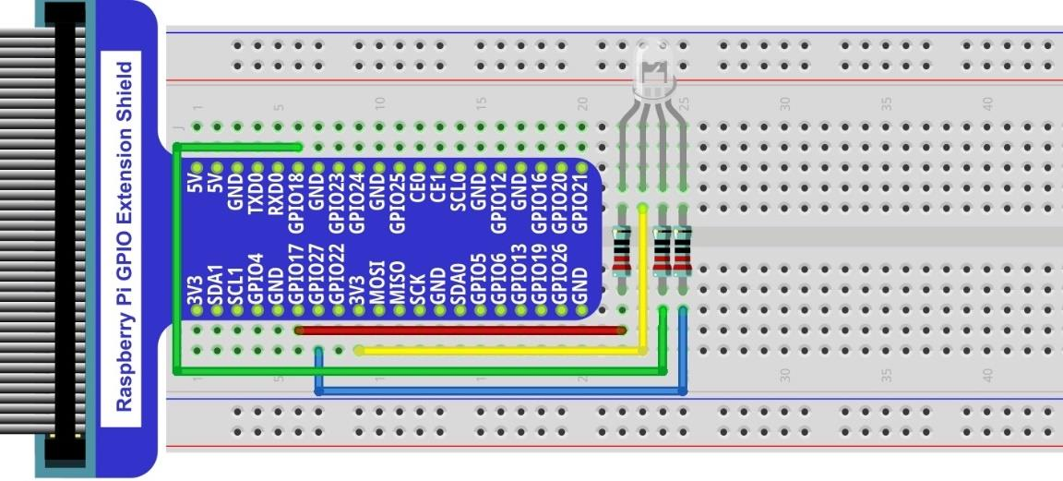>>> led.close() # when done

Day 1 – Linux command-line

**Linux command-line cheat-sheet**

Options surrounded by brackets are optional

ls List all files and directories in current working directory

cd mydir Change directory to a subdirectory called 'mydir'

cd .. Change directory to the parent directory

pwd Print the path of the current (working) directory

nano filename Open 'filename' in the text editor

Press ctrl+x to quit, follow prompts

cat filename Display the contents of the file (no scrolling)

less filename Display the contents of the file (allows scrolling)

Press q to quit when done

cp file1 file2 Copy file1, naming the new copy as file2

mv file1 file2 Rename file1 to file2

mv file1 dir1/ Move file1 into the directory dir1

rm file2 Delete (remove) the file named 'file2'

man rm View the manual for the 'rm' utility

mkdir dirname Create a directory with the name 'dirname'

rmdir dirname Remove the empty directory with the name 'dirname'

All of these utilities have switches to alter their functionality. Try: ls -l

Hidden files (ones that are preceeded with a period) can be viewed by using the -a tag on ls. Try: ls -al

**Hunting ghosts:** You need to find Inky, Blinky, Pinky, Clyde, Spooky, Funky, and Sue

ps -aux | less Piping - direct the output from one utility to another

xxd binaryFile View a file that doesn't display nice normally (pipe the output to less)

Absolute path - Specify the entire path structure, starting with /. Works from anywhere.

cd /home/pi/STEMCamp2022

Relative path - Specify from your current location

cd STEMCamp2022 Works if you're already in ~ (/home/pi)

cd .. Move to the parent directory of your current location

The Terminus game may help you get comfortable with some of these commands

<http://web.mit.edu/mprat/Public/web/Terminus/Web/main.html>

**Bar graph** - Each LED is controlled individually. 10 LEDs means 20 connections total

>>> led1 = LED(26) # etc

>>> led1.on() # you can control each led using on, off, blink

# remember to close all of them when done, so the interpreter knows you're not using them any more

>>> led1.close()

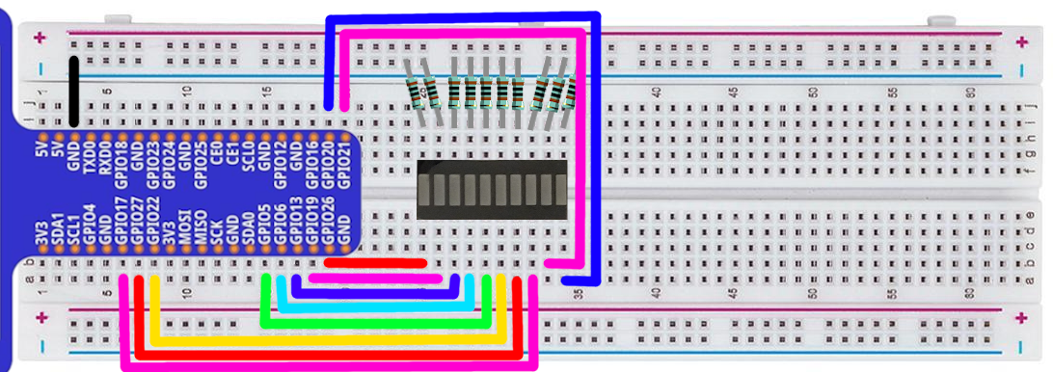

**7 Segment display**

This reduces the connections by having a common cathode

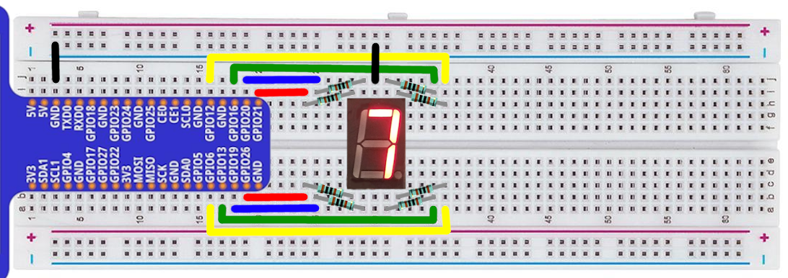

**LED Matrix Display**

Note the orientation of the matrix (the writing is on the top on this picture)

Connect each of the pins as shown, connecting through resistors for those in red

In the dotmatrix directory - try modifying the dots.txt (two blank lines between each frame)

python3 testmatrix.py

python3 matrix.py dots.txt

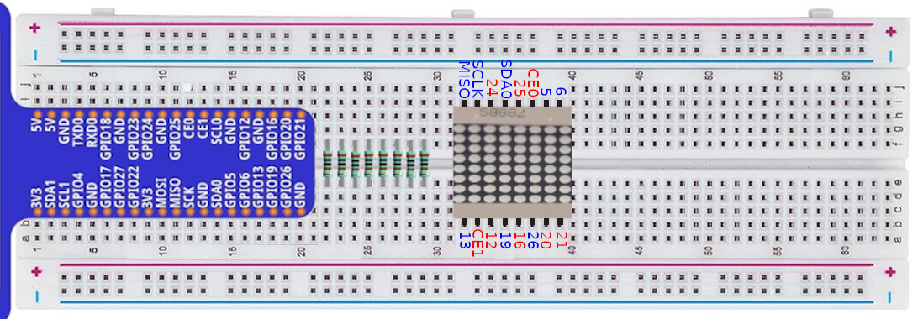

**Morse Code**

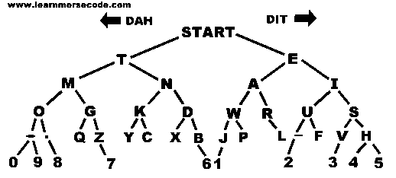

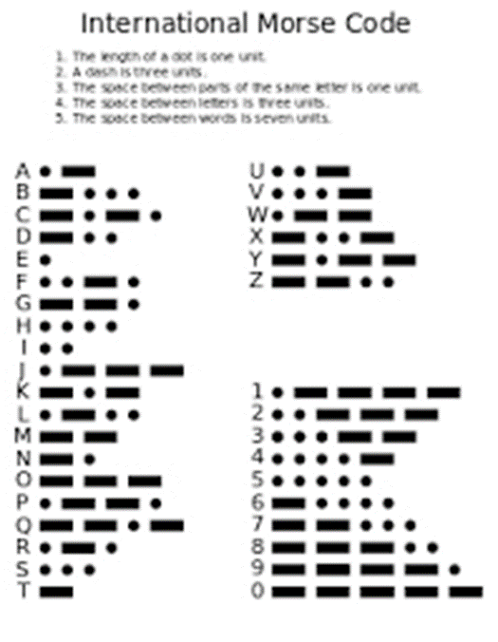

Connect an led to GPIO22 (like we did on page 1)

In the morseCode directory, run: python3 morseChallenge.py

How high of a score can you get?

**Serial to Parallel chip with LEDs (74HC595)**

Connect the LEDs through resistors. (I have them all attached to the ground rail in this picture)

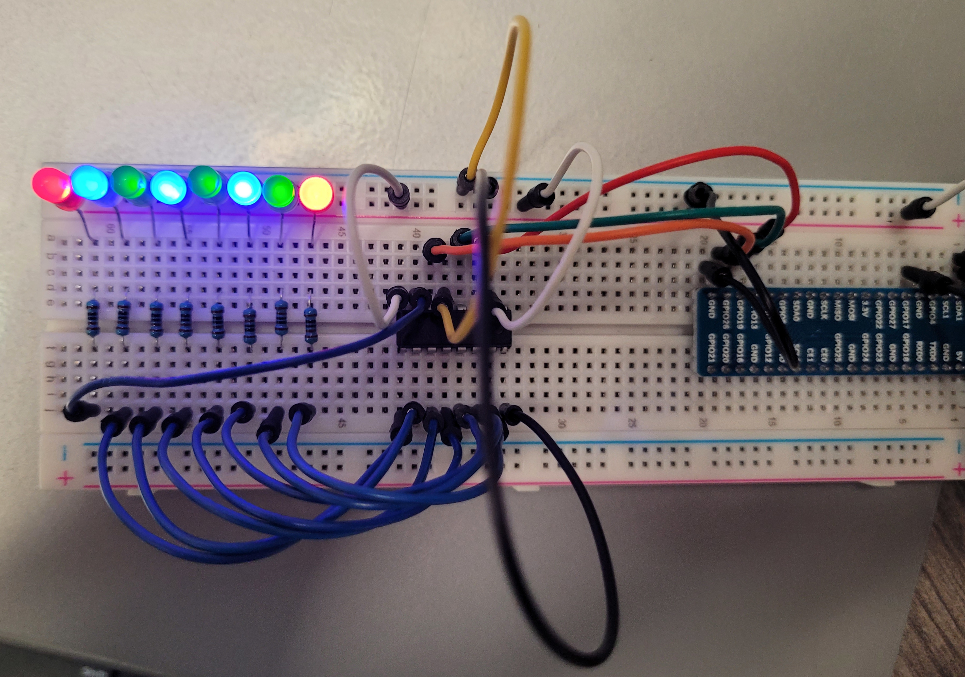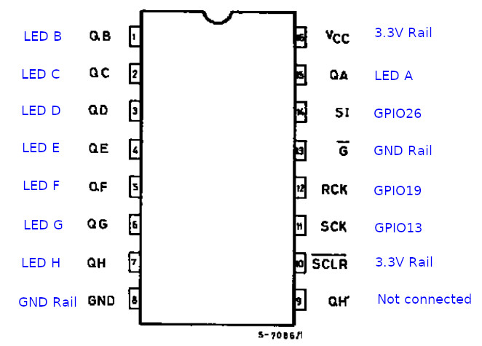In serialChip, python3 8light.py

Display any byte (by giving it 1s and 0s)

**LCD Screen**

python3 lcdi2c.py

pyth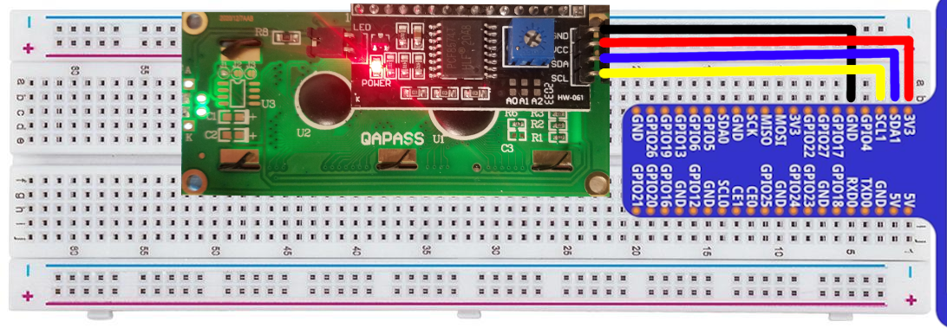on3 lcd_display.py

Ciphor usage examples

Show cipher help

**ciphor.py --help**

Encrypt the message, hello world, with a Caesar Cipher shifting characters 3 to the left. -c designates Caesar Cipher. The 3 designates the size of the shift, and -e is encrypt (shift to the right).

**ciphor.py -c 3 -e “hello world”**

Encrypt the message, hello world, with a key cipher with key “mykey”. -k designates a key cipher, -e is for encrypt and “mykey” is the key used for encryption.

**ciphor.py -k “mykey” -e “hello world”**

Decrypt the file, ciphered_message1.txt, using a Caesar Cipher and a shift of 3. -d designates decrypt (shift to the left).

**ciphor.py -c 3 -d -f ciphered_message1.txt**

Generate the signature for plain_text1.txt. -S will show the signature and -f designates an input file.

**ciphor.py -S -f plain_text1.txt**

Generate the letter frequencies for ciphered_message1.txt -s will show the statistics (letter frequencies) for the input text.

**ciphor.py -s -f ciphered_message1.txt**

Encrypt plaint_text1.txt and output the encrypted file into the file named encrypted_plain_text1.txt. -o sets the output file.

**ciphor.py -k “mykey” -e -f ciphered_message1.txt -o encrypted_plain_text1.txt**

If you want to generate your own values for the the RSA algorithm, you can use the worksheet found at https://www.cs.drexel.edu/~jpopyack/IntroCS/HW/RSAWorksheet.html

grep is a search tool in linux. It can search for fixed or dynamic patterns.

Typical usage:

**grep [options] [patterns] [file …]**

Look for the word bad in all files ending in .txt. The * is a wildcard and means to look for anything. The .txt designates the ending of the files to look for.

**grep “bad” *.txt**

Look for the word bad and the word http with anything in between the two. The .* designates any number of characters between bad and http.

**grep “bad.*http” *.txt**

Look for the words http or ftp. The () make a group and the | acts as an or. Thus, it looks for “ht” or “f” then “tp”.

**grep -E “(ht|f)tp” *.txt**

Look for three numbers, each between 0 and 9.

**grep -E “[0-9][0-9][0-9]” *.txt**

Look for parenthesis. Note that ( and ) are preceded by \. This will find open and close parenthesis with anything between.

**grep -E “\(.*\)” *.txt**

Look for two numbers a hyphen and three numbers.

**Grep -P “\d\d-\d\d\d” *.txt**

**.** Any character

**?** repeat 0 or 1 times (affects character to left like a? would search for 0 or 1 a)

**\*** repeat 0 or many times (affects character to left like a* would search for 0 or many a)

**+** repeat 1 or many times (affects character to left like a+ would search for 1 or many a)

**[a-dhlm]** match any of characters listed: a, b, c, d, h, l, m**.**

**\d** find any number (same as [0-9]—only works with -P option).

**\w** find any word (a word is defined as non-whitespace characters surrounded by whitespace, needs -P).

**\s find any whitespace characters (needs -P).**

View the password file: **cat /etc/passwd**

View the shadow file: **sudo cat /etc/shadow**

Install John: **sudo apt install snapd**

**sudo snap install john-the-ripper**

**sudo reboot**

Crack Passwords **john myshadowfile**

Specify a wordlist **john --wordlist=/usr/share/john/password.lst shadowfile**

Show already cracked passwords **john --show shadowfile**

Specify a format, if John is having trouble **john --format=md5crypt shadowfile**

List the hash formats that you can specify **john --list=formats**

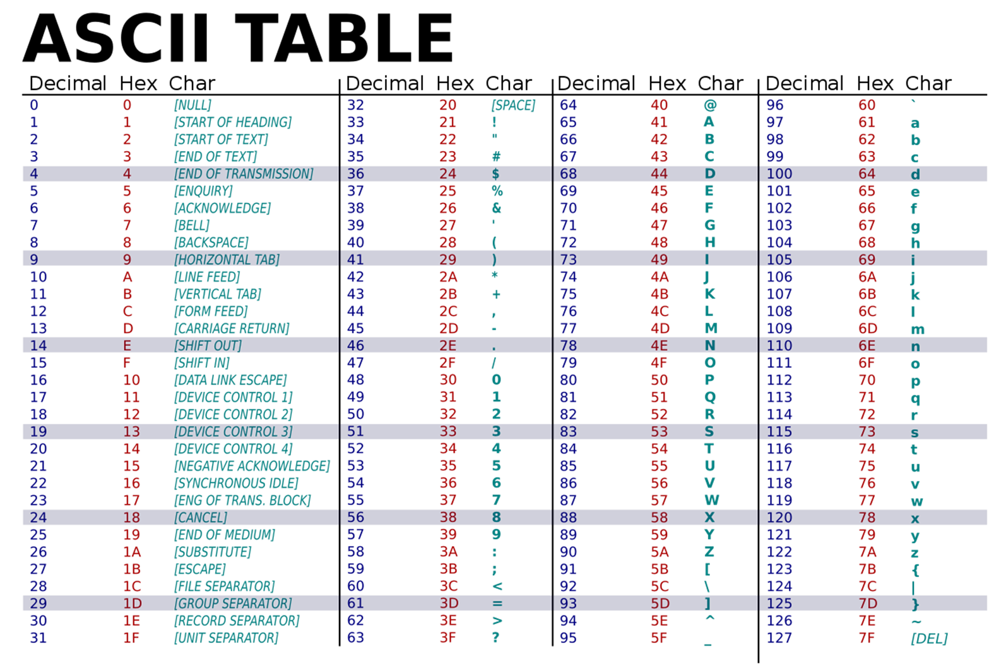

Day 4 – RFID reader

**RFID Reader**

readrfid.py display_rfid_data.py writeToRFID.py access_card.py

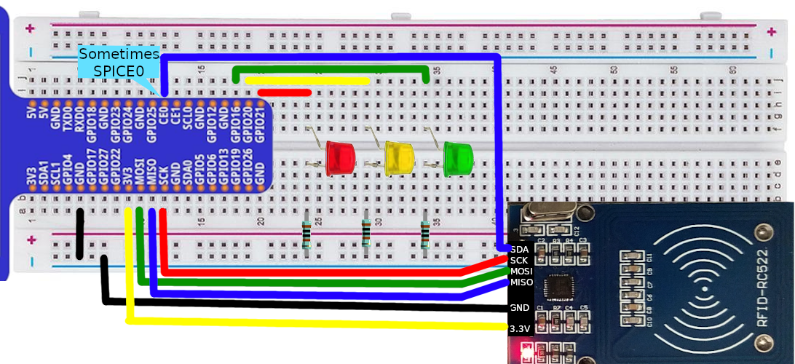

Day 5 – Hardware sensors

**PIR Sensor**

motiondetect.py

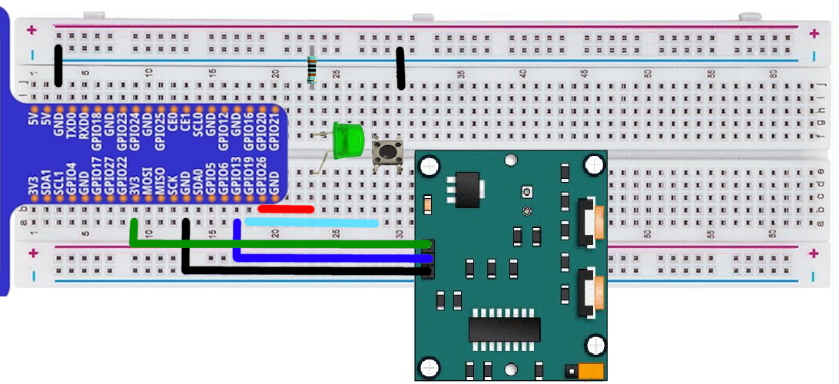

**Distance Sensor**

distanceSensor.py

